43.14: a)The energy released is the energy equivalent of 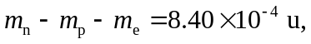
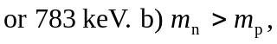 and the decay is not possible.

